Gulf Coast 10-13 Newsletter
If You Served, You Belong
Our next meeting will be on
Wednesday, May 18, 6:30 pm

Bob Federici, President
IMPORTANT PHONE NUMBERS
Operations Desk 1-640-610-5580
NYPD Pension 1-866-692-7733
Employee Benefits 1-212-513-0470
P.B.A. 1-212-233-5531
P.B.A. Retired 1-121-298-9246
P.B.A. Drug Plan 1-877-722-7911
D.E.A. 1-212-349-0424
S.B.A. 1-212-226-2180
L.B.A-C.E.A. 1-212-964-7500
Social Security 1-800-772-1213
G.H.I 1+800-358-5500
Empire Blue Cross 1-800-433-9592
Medicare A & B 1-800-333-7586
N.Y.C Health Line 1-800-521-9574
N.Y.P.D. (DIF) 1-212-374-5508
V.A. Benefits 1-800-827-1000

Stuart Rothbaum, Vice-President
Charlie Fugerie, Treasurer

Past Presidents
Bill Reilly, Bill Condon, Hans Fredericks
Joe Monteleone, Ed. Wright, Ed. Barker
Mike Lubrano, Bob Federici
Newsletter: Bob McGuire
Health and Welfare,
Jerry Plescia

We will continue
to hold our Meetings
every 3rd Wednesday of each
Month until further notice.

OUR COUNCIL IS ONLY AS STRONG AS OUR MEMBERS
Our next meeting will be at the Olympia Restaurant in Port Charlotte. You can go to the below web site to view their menu.
https://theolympiadiner.com/dinner/

Leaked Audio: Eric Adams Says He Will Fire Anyone Who Leaks Unapproved Messaging to the Media
New York City mayor Eric Adams warned of a press corps seeking "gotcha" moments and said anyone caught providing communications to the press without authorization of City Hall will be terminated, leaked audio reveals.
Addressing around 50 officials from city agencies on a Zoom call Thursday, Adams announced a new "discipline of message" policy to combat an "aggressive" media.
"We're dealing with a very aggressive press corps where there's an 'I gotcha' moment instead of 'I got you' and we need to be on top of that," he said, according to audio obtained by Politico.
Adams has previously criticized the media covering his administration for lacking the diversity he believed was necessary to cover a black mayor.
During Thursday's Zoom, Adams noted that messaging that was not supposed to be released had been leaked, and he planned to impose strict disciplinary measures in an effort to prevent additional leaks, going as far as to rid his administration of anyone who attempted to undermine it.
"The first few months we've noticed that press advisories have gone out or press releases have gone out and number one, we knew nothing about it or it was something that we were still contemplating here — and that's just not how I operate," Adams said.
He continued, "I'm a big believer in discipline, discipline of message and discipline of action ... I do not accept people sabotaging this administration. If people want to be hurtful or harmful to this administration, this is not the place you want to serve. And if I ever find out that happens, someone intentionally does something that is inappropriate, you will not work for me as the mayor."
While it remains unclear what communications Adams was referring to in announcing his new policy, the mayor and administration officials have contradicted one another on a number of key subject areas.
Adams said last month he wanted parents to decide whether to mask their 2-4-year-olds in schools while the mayor's new health commissioner, Ashwin Vasan, supported keeping the mandate in place. The mayor also said last month that he supported outdoor heaters after he was asked about a Fire Department official testifying at a City Hall hearing against the use of outdoor heaters.
Also last month, the NYPD's deputy commissioner for counterterrorism and intelligence alleged that the department never inappropriately spied on Muslims following the 9/11 attacks but Adams disputed that claim.
"What we did was wrong," Adams said at the time in response to the commissioner's claim. "We did some things that were wrong, and they will never happen under my administration."
Adams' new "city agency press release tracker" will require communication officials from dozens of departments to submit press releases, press conference plans or other public statements for City Hall to approve.
Seven staffers on the Zoom call told Politico that it is typical for a mayor to try to control messaging. But four officials who have worked for multiple mayors told the outlet that Adams' new policy to control communications goes beyond that of prior administrations.
"What is imperative to know [is] that you are assigned to an agency under a commissioner but you work for me," Adams said during Thursday's call.
"The commissioner leads an agency, but I lead the city," he continued. "I'm the mayor of the city and all communications that come through this city government is coming through my message."
The mayor explained that communications as basic as announcing a tree-planting volunteer event must still be vetted.
Adams said his staffers could come see him at any time to discuss concerns and that he was trying to create a "safe space to work in so we can be as productive as possible." He assured staffers that he would review submitted communications every morning and would not delay their work.
I REMEMBER THEM WELL, Subject: CHOKER THE BEST WE EVER WORE.... Love those Great Classy Coats
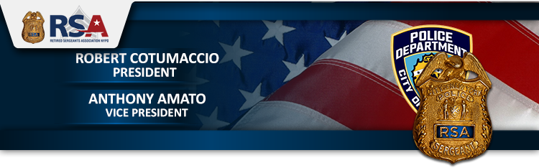

Dear Retired Sergeant,

We would like to update our members regarding the status of the City’s Medicare Advantage Plus Plan. As reported, on March 3, 2022, the City filled for a hearing of appeals. They also requested to be put on the calendar for the June 2022 Term and requested an expedited decision on the appeals.
Here is the Supreme Court of the State of New York Appellate Division's response:
“It is ordered that the motion is granted to the extent of directing the Clerk to maintain the appeal on this Court’s calendar for the September 2022 Term, to which Term the perfected appeal is adjourned.”
Stay Tuned!
RSA – Keeping Retirees Informed

Fraternally,
Bobby Cotumaccio, President
Tony Amato, Vice President

WELCOME! To the NYC Organization of Public Service Retirees Newsletter!
Hello Retirees! Today is Tuesday, April 12th. LOTS OF NEWS! Many keep asking about Co Pays, we address this in video 1. You must pay these, and please keep track of them in a file. We are still fighting this. Hopefully the Judge answers the argument this time around. If you are not sure what you should pay when you receive a bill, log into Medicare and your GHI (or other) and confirm that the bill was processed and you met your deductible. Co Pays are in effect once your deductible is met.
Video 2 below is today's update. Today, the Court said it would NOT hear our case before September. This gives us time to prepare and raise funds for the appeal and cross appeal. Yay us! 1.
4/8 Friday Night Update 2.
4/12 Tuesday Court Update and Q&A
We are advising that retirees continue opting out as long as the Alliance is accepting opt outs. This tells the City, "This plan stinks and we don't want it!" If they ever do bring it back, the city will have to restart the implementation process. If you need help please go to our website: OPT OUT **************** Your friends, and retirees in SOLIDARITY... The NYC Organization of Public Service Retirees **************
TO DONATE TO THE LEGAL FUND Donation Instructions to Support Our Class Action Suit Against the City T
If you need help please go to our website: OPT OUT
Our ID is: @NYCRetirees
If you are on this list, it is because you subscribed to hear what we are doing as an organization that represents all NYC Municipal workers in protecting their Health benefits in retirement. Currently, we have a FACEBOOK page located here: https://www.facebook.com/groups/888622578669131
If you are not on FACEBOOK, we will be updating you here. And Check our website for FAQ www.nycretirees.org
Thank you for signing up for our newsletter and pass this to a friend to sign up too
TO DONATE TO THE LEGAL FUND
Donation Instructions to Support Our Class Action Suit Against the City To Protect Our Retiree Healthcare: We worked decades for our benefits! Let’s make sure the City and the MLC don’t take them away! A suggested $25 Donation* will help start the fight to keep our current benefits. Give more if you can, and/or often! If you cannot meet the minimum suggested donation, we appreciate whatever you can give towards this fight for our benefits. We also added the option to make your donation recurring (monthly) as was requested. The fundraiser group is incorporated as a Non-Profit. ALL proceeds go to fund the legal challenge and not to anyone in the Organization. Volunteer retirees are running this effort.
TO DONATE, HERE ARE 4 SIMPLE WAYS! 1.Zelle using email NYCOrgofpublicserviceretirees@gmail.com
2. Make your check out to: NYC Organization of Public Service Retirees PO Box 941 Venice, FL 34284 (our treasurer lives in FL)
3. Or click on this Paypal link: https://www.paypal.com/donate/?hosted_button_id=Q4VWJEYVJ9HTW&Z3&fbclid =IwAR0pEOc51x9xhc-CBb8vqAIkX97Bgg1Z02f1r9gQh9S3dOsVmAdob5jBbw8
4. We Now Accept Donations via VENMO. VENMO is a Phone App or can be used on a PC or Tablet. You can download and install the Phone App from the Android Play Store or Apple App Store. Please follow the instructions to Sign Up. Please read and understand how VENMO works before you donate! There may be fees involved using this method.

Eric Adams asks NYPD commanders to brainstorm plans to combat crime
April 27, 2022 7:15pm
Updated
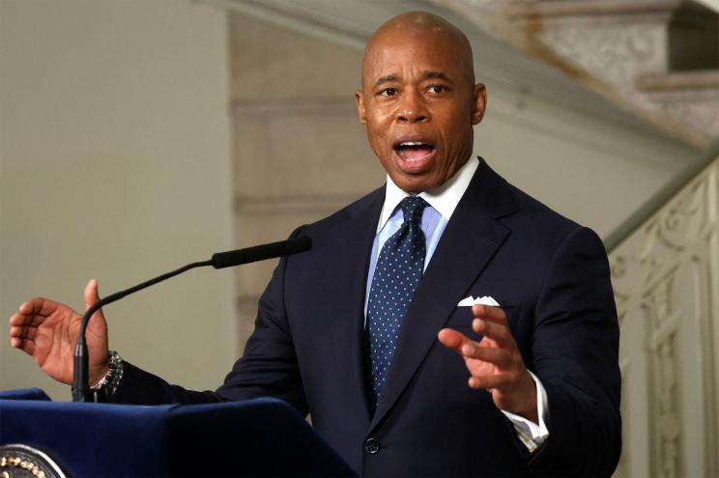
Mayor Eric Adams has called a meeting with the NYPD’s commanding officers to solicit ideas about combatting soaring crime in the Big Apple ahead of the historically bloody summer month, The Post has learned.
Hizzoner is set to sit down with the COs Saturday afternoon in One Police Plaza — and he’s asked them to each bring three plans to reduce crime in their patrol areas, according to sources.
Adams has also requested statistics on crime, summonses, homeless encampment clearings and Civilian Complaint Review Board cases, as well as information on each command’s integrity control officer, the sources said.
The mayor confirmed the upcoming meeting during an interview with The Post’s editorial board on Wednesday.
“I have a major meeting this weekend with all of my commanders,” he said. “We’re going to sit down for several hours to get our summer plan in order, as well as, think how we deploy police.”
The planned sit-down is similar to the department’s Compstat meeting in which COs are grilled on crime in their patrols areas.
But not everyone is taking it seriously. One source with knowledge of the meeting quipped that commanders think bringing ideas to combat crime is a “joke.”

Adams asked the commanding officers to each bring three plans to reduce crime in their patrol areas.Spencer Platt/Getty Images
The gathering comes as Adams ends his fourth month in office with crime and gun violence still on the rise — after sailing to a mayoral victory campaigning on getting the bloodshed under control in Gotham.
As of Sunday, shootings remained up 2% from the same time last year, when the city was in the midst of a historic uptick in gun violence that started in the early weeks of the pandemic.
RETIRED NYPD COP LIVING IN IRELAND TRIGGERS MASSIVE RAID OVER HIS OLD GUN: https://tinyurl.com/2p87j4c9

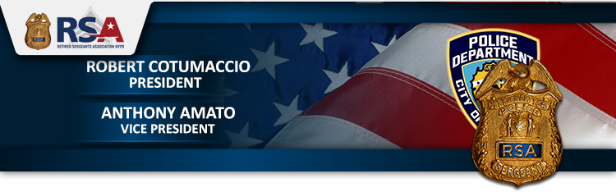
Dear Retired Sergeant,
For the past six months, we have been informing our members about the City's attempts at implementing a new Medicare Advantage (MA) Plus Plan. Their plans were to provide this MA plan at no premium. At the same time, they were planning to CHARGE a premium of @ $192/month/per Medicare individual if you opt to stay with GHI Senior Care. For a member and their spouse on Medicare it would cost an outrageous premium of just shy of $400/month. Because of this, most Medicare retirees would have no choice and be forced to accept the new MA plan.
Every Medicare City retiree has the NYC Organization of Public Service Retirees (https://nycretirees.org/) and their president, Marianne Pizzitola, to thank for leading the fight and taking the City to court putting a stop to this injustice. As we reported, on March 3 rd, Manhattan Supreme Court Justice Lyle Frank ruled that the City could not charge retirees who wanted to opt out $192/month to keep GHI Senior Care.
While the battle was won, the war still wages.
The City has filled their appeal. Every City retiree, whether you are on Medicare or not, should support this great organization. The NYC Organization of Public Service Retirees needs every one of us to join and support them in preventing the City from reducing our Health Care benefits or charge us a premium to keep what we have. Every City employee/retiree and their dependents’ Health Care is at risk. They will come after those City retirees not on Medicare as well as Active City workers next!!
I strongly recommend that you visit their website and please support them at: https://nycretirees.org/ RSA – Keeping Retirees Informed!

Fraternally, Bobby Cotumaccio, President, Tony Amato, Vice President

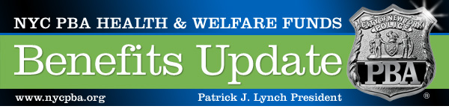

COMING SOON: NEW & IMPROVED PBA DENTAL BENEFITS!
Dear PBA Member:
I am pleased to announce that dramatic improvements are coming to your PBA dental benefits.
Beginning July 1, 2022, the PBA is partnering with Cigna Dental as our new dental benefits provider for both active and retired members.
Cigna will replace the PBA’s current self-administered dental plan. As a result, members will have access to:
- MORE Dentists & Specialists: +149,000 providers NATIONWIDE
- MORE Benefits: adult orthodontia coverage for active members, enhanced dental implant coverage and other additional coverage
- MORE Convenience: Easy-to-use app, 24/7 customer support, faster claims processing
At a time when workers across the country are seeing their benefits cut, the PBA is able to improve benefits thanks to our careful management of the PBA Health & Welfare Funds over the past two decades, as well as our hard-won gains at the bargaining table – especially the Health & Welfare Fund escalators that automatically increase the City’s contribution to the Funds with each general wage increase we receive.
Over the next several weeks, we will send you additional information to help you prepare to use your new Cigna benefits. Please monitor your mail, email and the PBA social media channels for additional updates.
Fraternally,
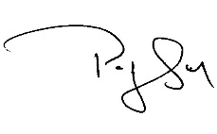
Patrick J. Lynch
President

Dear RSA Member,

The SBA is prioritizing the passage of Senate Bill S8664 of the 2021-2022 Legislative Session, introduced by Sen. Andrew Gounardes. In summary, this Bill would modify the current Tier 3 pension to eliminate the Social Security offset currently attached to Tier 3 Members.

This Bill is currently in the New York State Senate Committee on Civil Service and Pensions. The SBA leadership continues to meet with legislators to advance this important Bill.

However, for us to be successful, we need the membership to participate in the process. While the advocacy of the SBA Leadership is important, it is often what legislators hear from the "voters back home" that has the greatest impact on whether an elected official will support matters that are so important to the policing profession, our families, and the communities in which we live and serve.

We are asking the RSA membership to reach out to the members of the New York Senate Committee on Civil Service and Pensions. They have the ability to move this Bill from the Committee to the full Senate. Please share this e-mail with family, friends, and all members of law enforcement. You can use the following link to find your Senate District, https://www.nysenate.gov/find-my-senator

Sample Email

Dear Senator _______________________

As a resident of New York State, Senate District __________________, I urge you to support Senate Bill S8664 of the 2021-2022 Legislative Session. This Bill is extremely important for the policing profession to recruit the most qualified individuals, as well as incentivizing invaluable veteran officers to not retire, improves police morale at a time it is at its lowest in decades, and ensures a sense of fairness to the statewide policing profession. I cannot stress enough how important your support of this Bill is to myself, my family, and the residents of Senate District _____________________

Name (optional) Date:

Senators
Joseph Addabbo Jr. (D) John Mannion (D)
15th Senate District 50th Senate District
District Phone: 718-738-1111 District Phone: 315-428-7632
Albany Phone: 518-455-2322 Albany Phone: 518-455-3511
E-mail: addabbo@nysenate.gov E-mail: mannion@nysenate.gov

Fred Akshar (R) Diane Savino (D)
52nd Senate District 23rd Senate District
District Phone: 607-773-8771 District Phone: 718-727-9406
Albany Phone: 518-455-2677 Albany Phone: 518-455-2437
E-mail: akshar@nysenate.gov E-mail: savino@nysenate.gov

Andrew Gounardes (D) Alexis Weik (R)
22nd Senate District 3rd Senate District
District Phone: 718-238-6044 District Phone: 631-360-3356
Albany Phone: 518-455-3270 Albany Phone: 518-455-2950
E-mail: gounardes@nysenate.gov E-mail: weik@nysenate.gov
Robert Jackson (D)
31st Senate District
District Phone: 212-544-0173
Albany Phone: 518-455-2041
E-mail: jackson@nysenate.gov

JUNETEENTH IS A PAID HOLIDAY FOR NYC WORKERS STARTING THIS YEAR
https://tinyurl.com/yajnrtm

Miss me yet? Guess what’s for dinner.

